Issue 1: The global graph much better now but still has some issues.
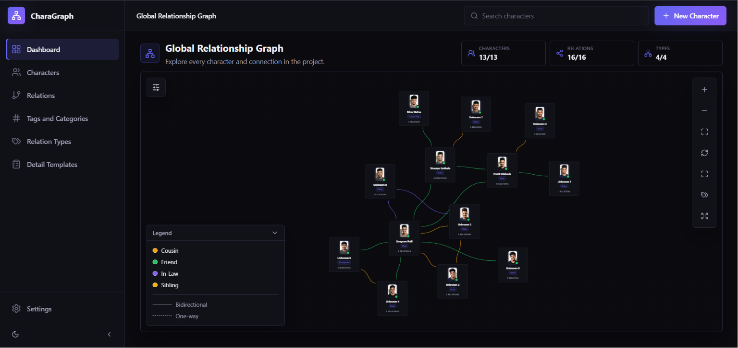
As you can see, the graph is extremely better than before. But still has some crossings which would have been avoided. Like this (manually changed):
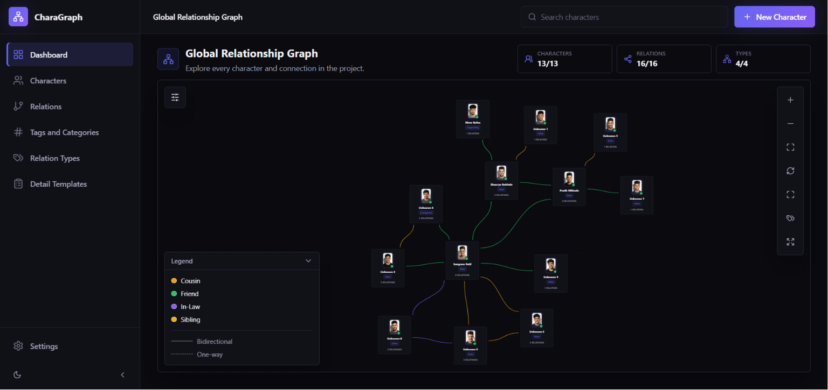
Location: dashboard – global character graph

